AI ASSISTED CODING
Lab Assignment-3.5
NAME: D.PAVAN
HT.NO: 2403A52L07
BATCH: 50

Task 1: AI-Generated Logic Without Modularization (String Reversal Without Functions)

- Scenario
You are developing a basic text-processing utility for a messaging application.

- Task Description
Use GitHub Copilot to generate a Python program that:
  - Reverses a given string
  - Accepts user input
  - Implements the logic directly in the main code
  - Does not use any user-defined functions

- Expected Output
  - Correct reversed string
  - Screenshots showing Copilot-generated code suggestions
  - Sample inputs and outputs

PROMPT:
# WRITE A PYTHON CODE FOR REVERSAL OF A STRING WITHOUT FUNCTIONS

CODE:
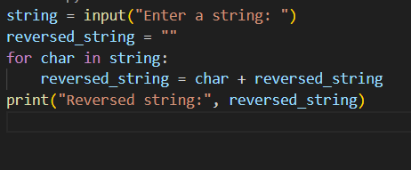
OUTPUT:
JUSTIFICATION:
- The program prompts the user to enter a string.
- It initializes an empty string to hold the reversed version.
- It iterates through each character of the input string.
- For each character, it prepends it to the reversed string.
- Finally, it prints the reversed string to the console.

TASK-2

Question 2: One-Shot Prompting (GCD of Two Numbers)
Write a one-shot prompt with one example to generate a Python
function that finds the Greatest Common Divisor (GCD) of two numbers.
Example:
Input: 12, 18 → Output: 6
Task:
• Compare with a zero-shot solution.
• Analyze algorithm efficiency.
PROMPT:
CODE:

OUTPUT:

JUSTIFICATION:

TASK-3
PROMPT:
CODE:

OUTPUT:
EXPLANATION:

TASK-4

TASK-5

PROMPT:
CODE:

OUTPUT:

Justification:

